Breezy Campaigns

## What we do

We’re building the first and last employee that any solo service pros will need to run their business, starting with a business phone number + AI frontdesk that can handle inbound/outbound calls + text messages to customers across their entire lifecycle. We have hundreds of customers ranging from verticals like home services, instructors, consultants and professional services. We believe in a world where millions of people can offer their services and grow their business without needing to grow headcount for operational work. We recently raised millions of dollars from top vcs, as well as some key openai employees (chief product officer, chief technical advisor to ceo, head of bd) and are looking to grow.

## Why Breezy Campaigns

Imagine telling your CRM, “Hey, we’d love more five-star Google reviews,” or “Could we nudge weekend foot-traffic?”—and then getting out of its way. That’s the promise of **Breezy Campaigns**, a lifecycle marketing engine that sits atop the same messaging rails as the rest of Breezy, but swaps out committee-built email trees for an AI that just gets on with it.

Think of it as the “Tell me what you want, then go make tea” button. Punch in a goal—“Stack five-star Google reviews,” “Fill Saturday with bookings,” “Upsell Service X to last year’s buyers”—and the AI chooses which customers to ping, which channel to use, and how often to nudge without sounding like a bot suffering an existential crisis. The interface is blissfully sparse: goal, tone, and a big green “Run.” No marketing jargon, no thousand-line drip sequences.

Their contact lists are sitting there. Breezy Campaigns turns that latent asset into an always-on salesperson who never takes lunch, never goes off-script, and—being software—never asks for commission.

## Current State of the world

We have a basic system to manage sms followups

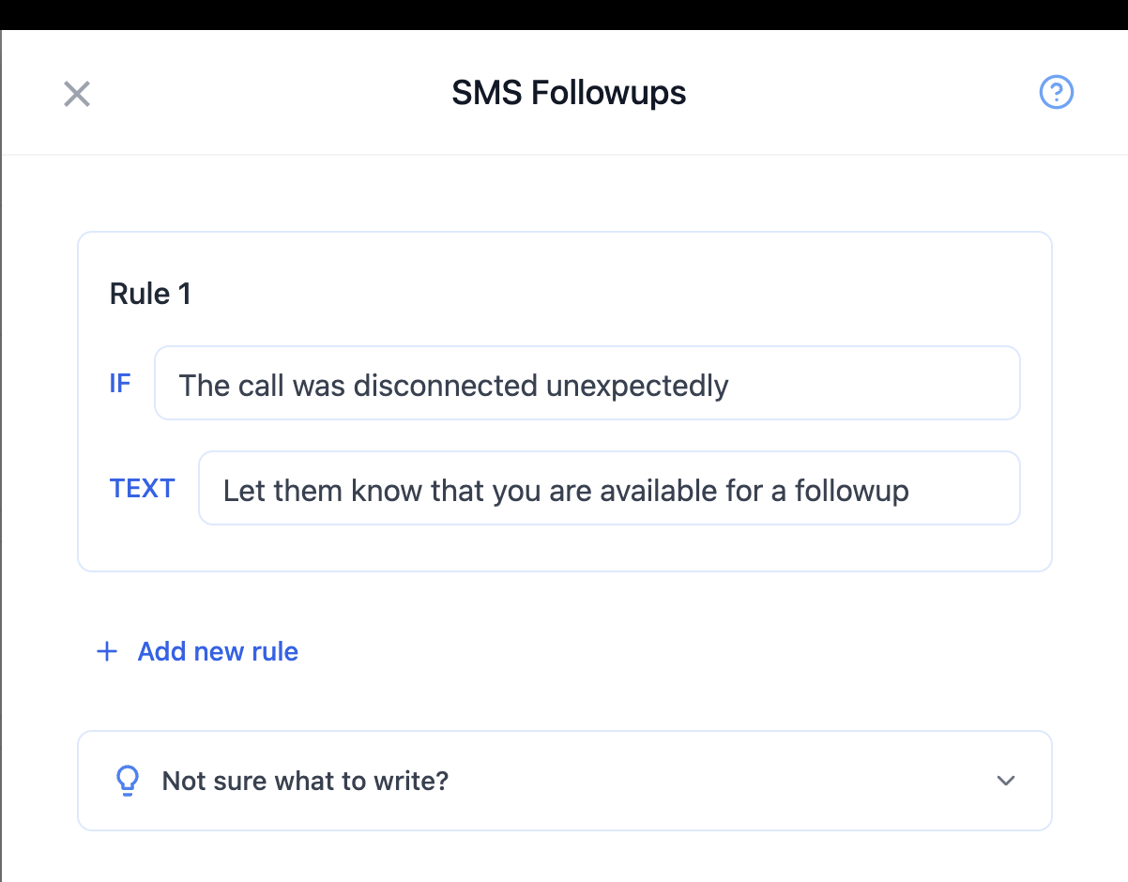

|  | **Path** |
| --- | --- |
| **Backend** | socratic_systems/app/models/breezy/post_call_action_config.rb |
| **Frontend** | breezy-fe/components/serviceProvider/dashboard/post_call_actions/PostCallTextRules.tsx |

## Low Level Lifecycle

Define a segment / condition and the sort of message to send them. Like we have for post calls hooks basically.

E.g we can define something like:

**If:** “User has paid me before and he is happy with the results and i haven’t nudged him about it before”

**Then:** “Message him to give us a 5 star review”

A more systemic way to do this is a tree kind of system like in Braze (behind the scenes) but i do think that it should be available to the user as raw text sort of thing rather than a visual. Maybe we can put limits on the complexity of it.

## High Level Lifecycle

You should be able to say things like “find me customers for this saturday”, or “increase my google reviews” or “get me some customers for next week for task x” and the system would create a low level lifecycle campaign automatically that will attempt to do this.

It’s important to give the professional a preview of this and give them an ability to give high level feedback to it (both in the preview phase) and when the campaign has started already. Maybe even before the preview phase we do an “active learning” sort of thing and ask the professional what they think about various things.

## High Level vs Low Level

| **High Level ✅✅** | **Low Level ❌❌** |
| --- | --- |
| Goal based definition  Easy to understand preview  Active learning  Improves and personalizes over time  Easy to give feedback to |  |

## Breezy Campaigns - Phases

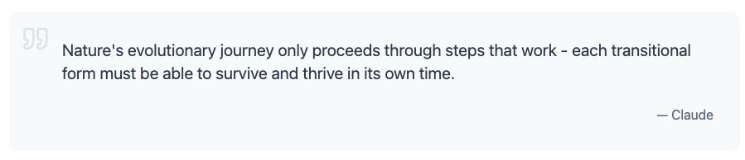

The above is equally true for product development. Each “phase” of the product should provide value to the users. Breaking product development into phases allows us to “close the loop” and quickly get feedback from users. Ensuring that we generate maximal value to our users. This is a tentative outline for the project:

**Phase 1: Low Level - Campaign Configuration**

Allow our users to configure lifecycle campaigns using mostly English. A campaign is basically a rule defining a segment of users to contact (and when to contact them) and what to say to them.

**Phase 2: High Level - Goal Configuration**

Proactively make suggestions on what campaigns the user can consider. In the backend, a high level configuration generates a low level one.

**Phase 3: Compliance**

When a customer wants to do lifecycle marketing we need to register an A2P campaign. I think we can mostly automate this.

**Phase 4: Image and Video Assets**

Some way to give our users a neat looking permanent link (e.g “jay-the-plumber.bree.ze” and setup the DNS for them). Ideally it’s all cached for speed and maybe using CDN.

**Phase 5: Email**

AI suggests templates and nice visuals.

**Phase 6: Analytics**

Tell our users how well they did. Show them the performance of different campaigns.

## Appendix

| **Good / Tasteful ✅✅** | **Bad / Spammy ❌❌** |
| --- | --- |
|  |  |
| Tailored details (name, context, recent job) | One-size-fits-all broadcast |
| Sent exactly when the need is fresh (e.g., right before summer heat) | Random or repetitive pings |
| Highlights a clear customer benefit (e.g., lower bills, free filter) | Self-centered hard sell |
| Single, obvious next step (“Reply COOL to book”) | Multiple or hidden asks |

## 